WEEK 2

1.

AIM : WRITE A PROGRAM TO PRINT SIZE OF ALL DATATYPES AND THEIR FORMAT SPECIFIER

DESCRIPTION : Using “print f “ statements we need to print the size of all datatypes and their format specifiers.

ALGORITHM:

1.Start

2.Declare datatypes char, int, float, double, long, short and void

3.Display size of char = 1 byte

4.Display size of int = 4 bytes

5.Display size of float =4 bytes

6.Display size of double = 8 bytes

7.Display size of long = 4 bytes

8.Display size of short = 2 bytes

9.Display size of void = 1 byte

10.Stop

FLOWCHART : 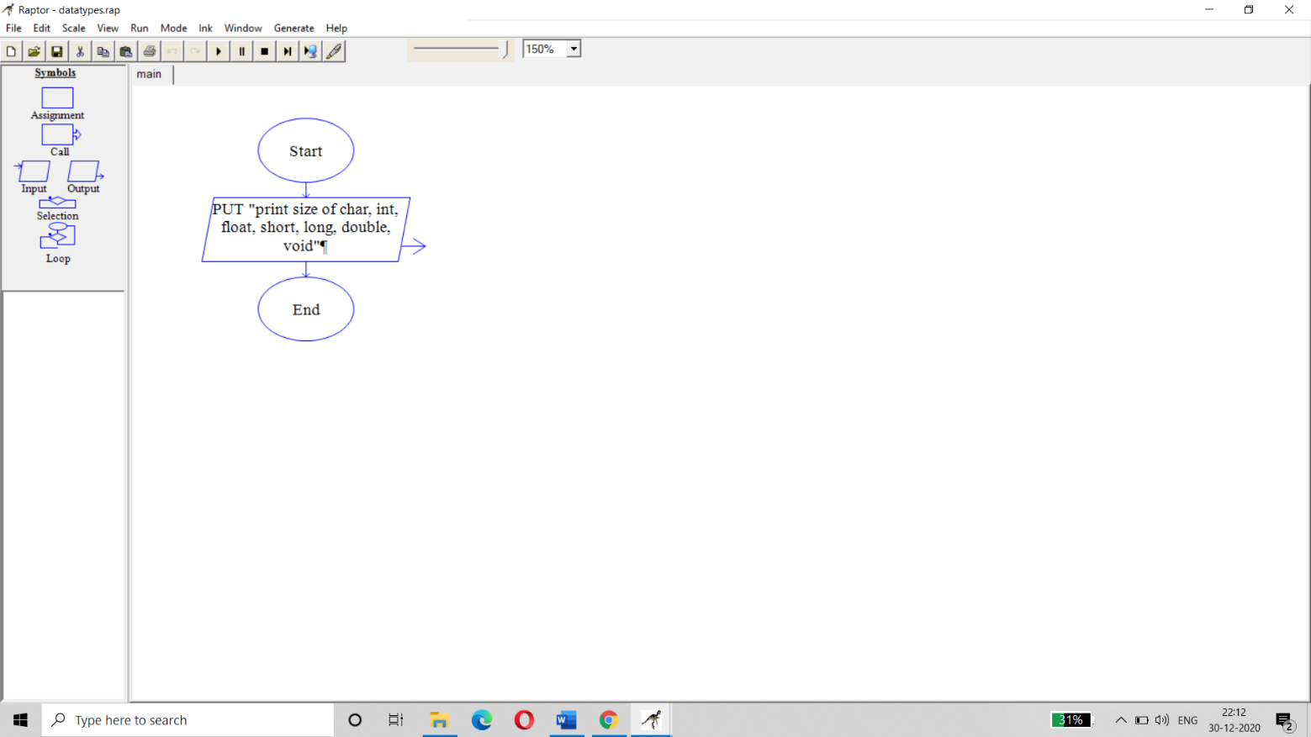

PROGRAM:

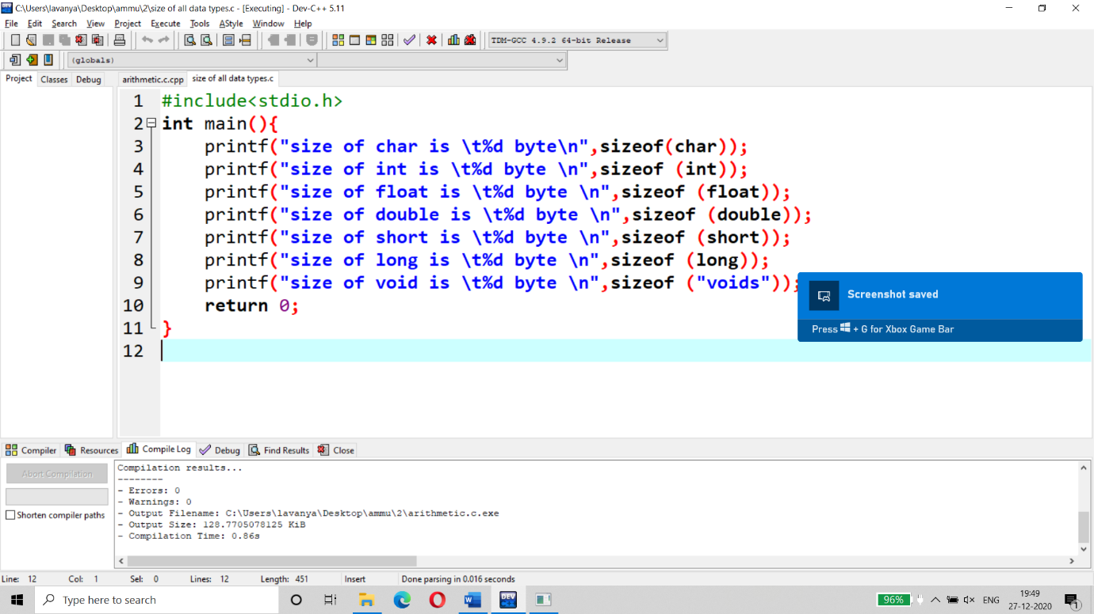

EXPECTED OUTPUT:

Size of char is 1 byte

Size of int is 4 bytes

Size of float 4 bytes

Size of double is 8 bytes

Size of long is 4 bytes

Size of short is 2 bytes

Size of void is 1 byte

ACTUAL OUTPUT :

*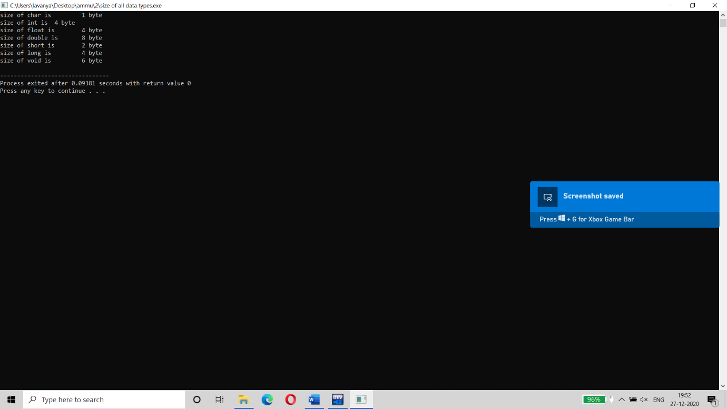*

CONCLUSION : We concluded that by using “ print f “ statements we found the size of all Data types and their format specifiers.

2.

AIM : WRITE A PROGRAM TO PERFORM ALL ARITHMETIC OPERATIONS

DESCRIPTION : Using “Print f “ statements we need to calculate the arithmetic operations of certain values.

ALGORITHM :

1. Start
2. 2.Read a,b,add,sub,mul,div,mod
3. Add=a+b
4. Sub=a-b
5. Mul=a\*b
6. Div=a/b
7. Mod=a%b
8. Print add,sub,mul,div,mod
9. stop

FLOWCHART : 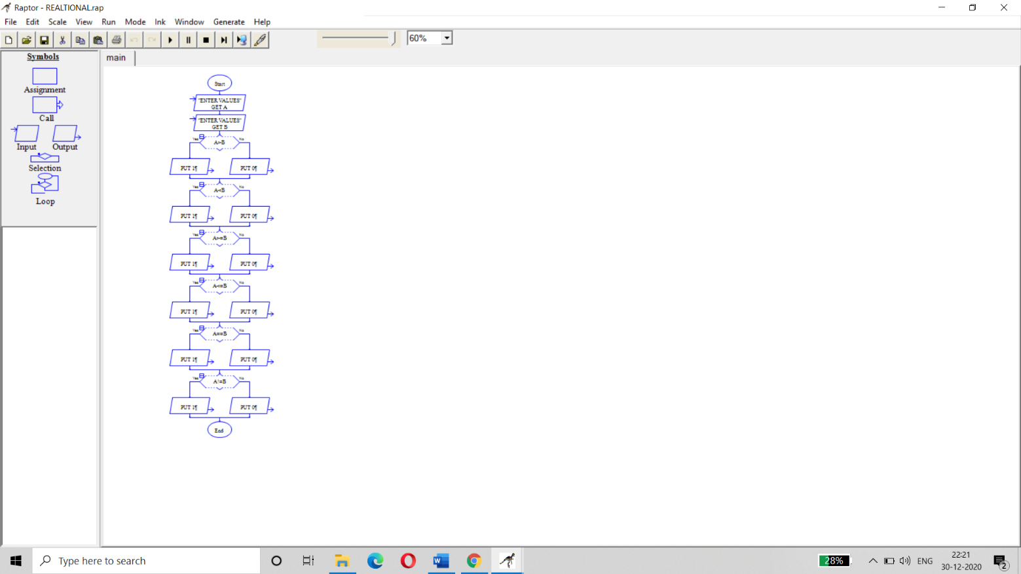

PROGRAM:

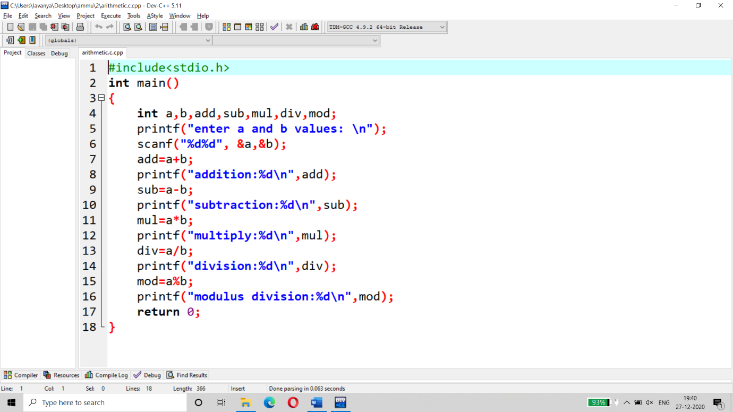

EXPECTED OUTPUT :

Add=10

Sub=0

Mul=25

Div=1

Mod=0

ACTUAL OUTPUT : 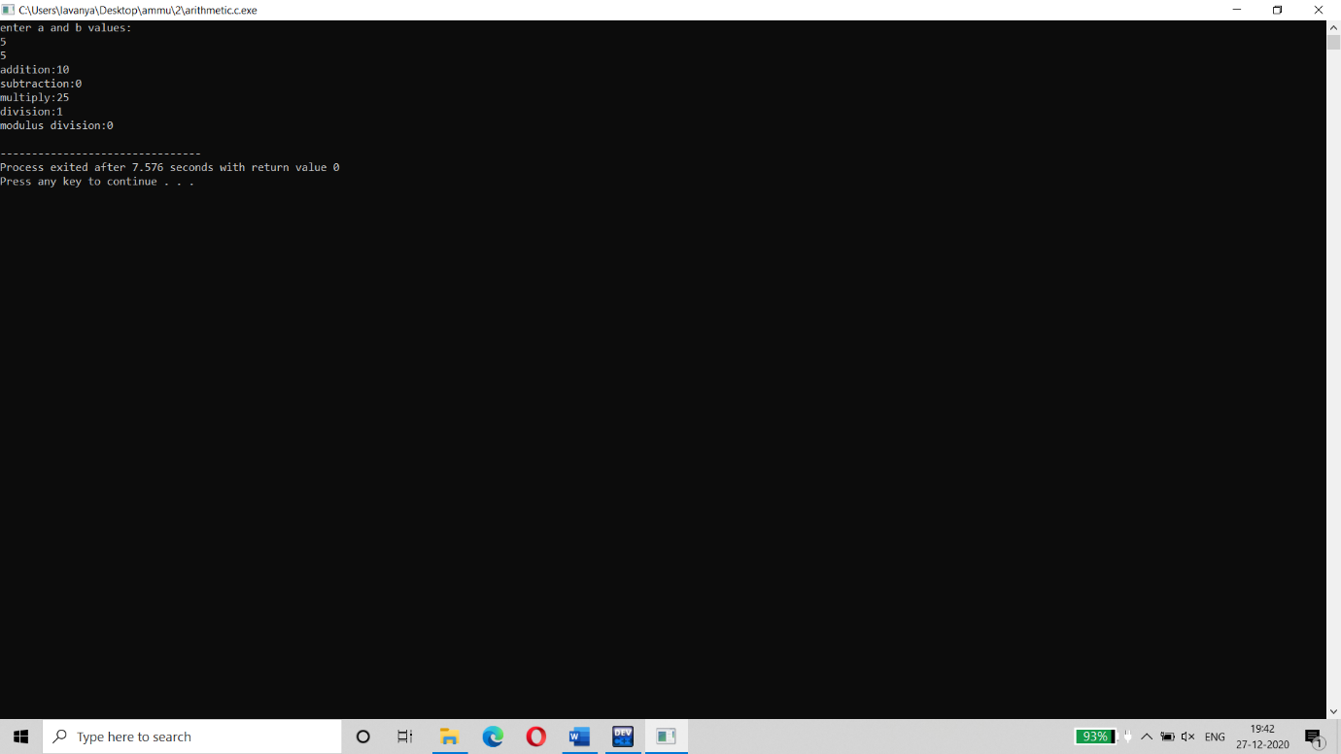

CONCLUSION : We concluded that by using “print f “ statements we calculated all the arithmetic operations.

3.

AIM : WRITE A PROGRAM TO PERFORM ALL RELATIONAL OPERATIONS

DESCRIPTION : Using “print f “ statements we need to perform all the relational operations.

ALGORITHM :

1.Start

2.Declare a,b

3.Print "a=1,b=2 values" through keyboard

4.If a >b then,

4.1 Print"1 for true "

Else

4.2 Print "0 for false"

5.If a<b then,

5.1 Print "1 for true"

Else

5.2 Print "0 for false"

6.If a>=b then,

6.1 Print"1 for true "

Else

6.2 Print "0 for false"

7. If a<=b then,

7.1 Print"1 for true "

Else

7.2 Print "0 for false"

8.if a==b then,

8.1 Print"1 for true "

Else

8.2 Print "0 for false"

9.If a!=b then,

9.1 Print"1 for true "

Else

9.2 Print "0 for false"

10.Stop.

FLOWCHART :

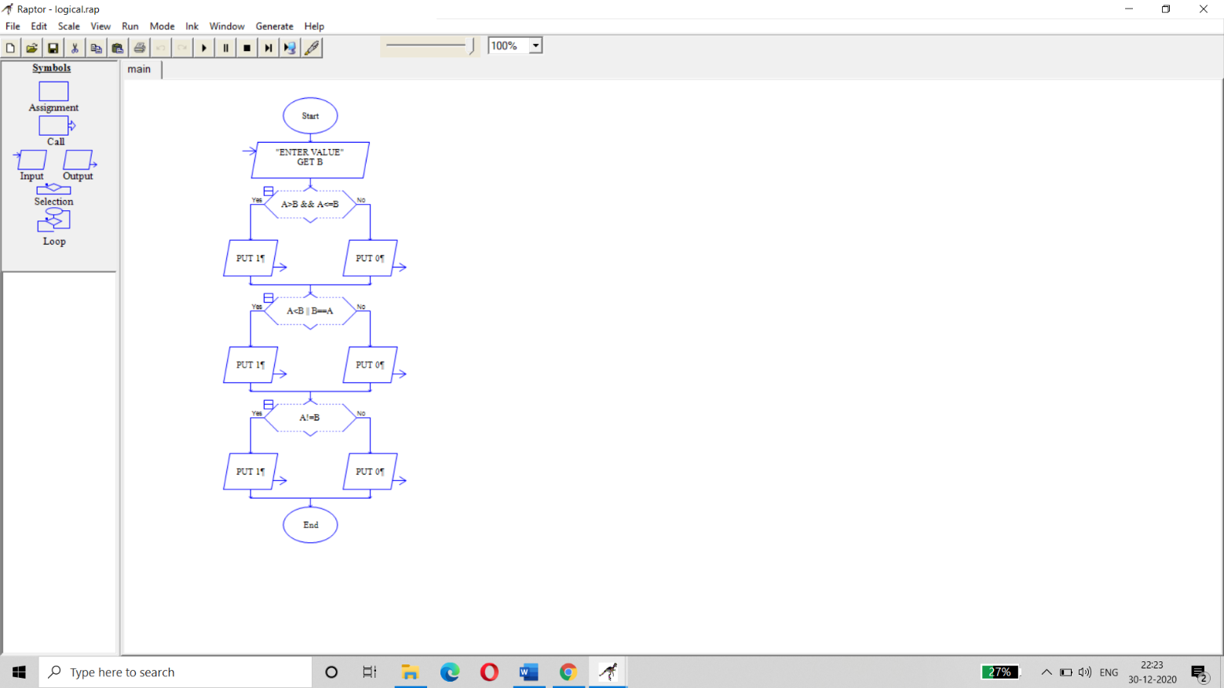

PROGRAM:

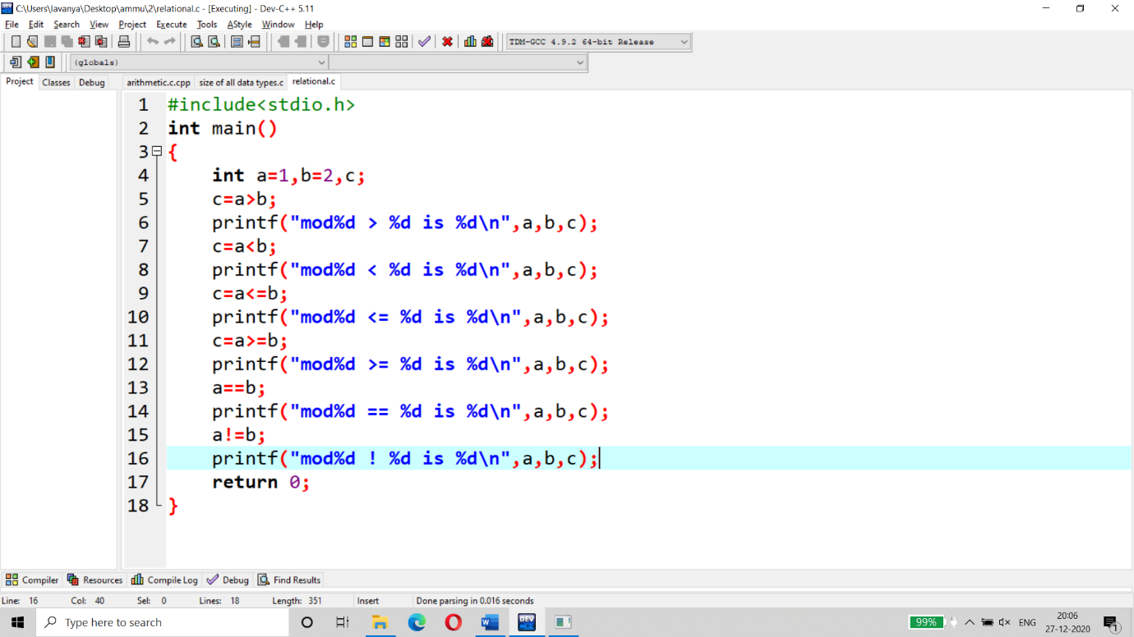

EXPECTED OUTPUT :

C=a=1,b=2

If a>b then it is 0(False)

If a<b then it is 1(True)

If a<=b then it is 1(True)

If a>=b then it is 0(False)

If a==b then it is 0(False)

If a!=b then it is 1 (True)

ACTUAL OUTPUT:

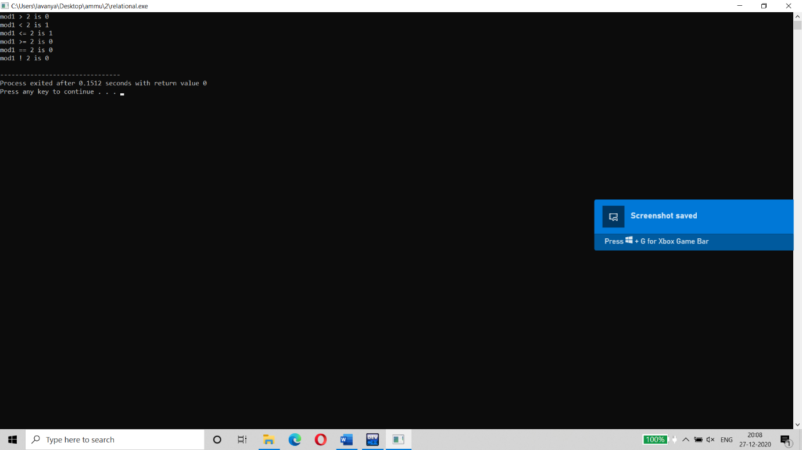

CONCLUSION : We concluded that by using “print f “statements we can perform the relational operations.